**Experiment-5: To Implement The Structure Of The Table**

**Student Name:- Neha Sharma UID:- 20BCS4576**

**Branch:- CSE-IOT Section/Group:- A**

**Semester:- 3rd Date of Performance:- 23/09/2021**

**Subject Name:- DBMS LAB Subject Code:- 20CSP-233**

**1. Aim/Overview of the practical:-** To implement the structure of the table.

**2. Task to be done:-** Implementation of DDL and DML commands of SQL with proper Input

queries syntax and the output.

**3. Contraints in SQL:**

**1. Adding NOT NULL Constraint**

**Command:- NOT NULL**

**Purpose**:- If you want to ensure that a column must always have a value i.e., it should not be left blank, then define a not null constraint on it. Null value can be inserted into the columns of any data type. Not null constraint can only be applied at column level.

**Syntax:-**

Column_name data­_type(size) **NOTNULL**

**Example:**

create Table Persons(ID number(10)NOT NULL, Lastname varchar(255) NOT NULL, Firstname varchar(255) NOT NULL, Age number(10));

DESC Persons;

**Output:-**

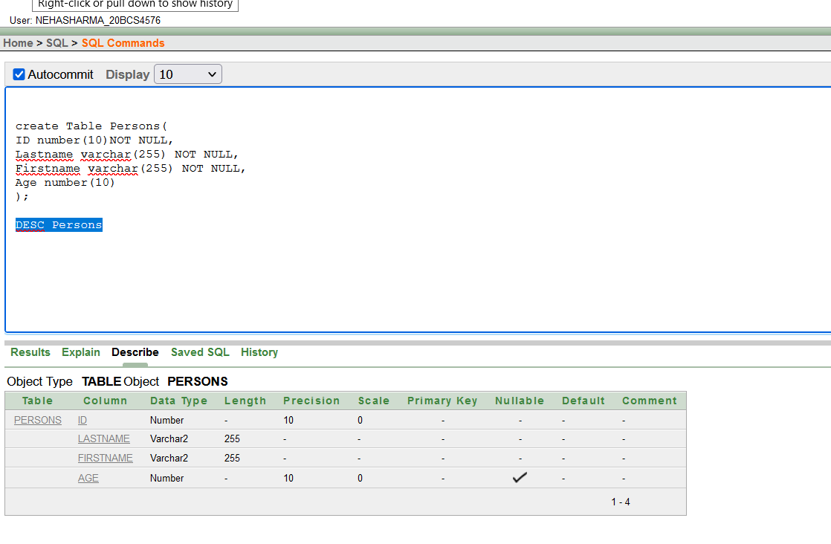

**2. Adding Unique Constraint**

**Command:-** UNIQUE

**Purpose:-** The UNIQUE constraint ensures that all values in a column are different. you can

have many UNIQUE constraints per table.

**Syntax: -** CREATE TABLE table_name (...column_name data_type UNIQUE ... );

**Example:-** Create Table Student1(Roll number(6) UNIQUE, NAME Varchar2(10), Address

Varchar2(20));

DESC Student1;

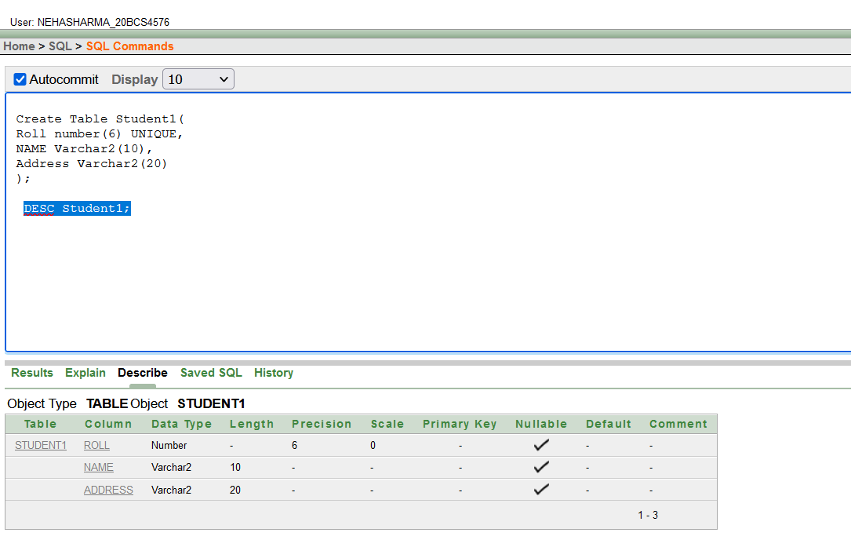

**3. Adding a Primary key**

**Command- Primary Key**

**Purpose:** - A primary key column in a table has special attributes: It defines the column as a mandatory column i.e., the column cannot be left blank.

The NOT NULL attribute is active. The data held across the column must be UNIQUE.

**Syntax:** - Defined at column level: Column name datatype(size) Primary Key Defined at table level

Primary Key (column name1, column name2,….., column name n)

**Example: -**

**Defined at column level:**

Create Table Person2(Roll number(6) PRIMARY KEY,NAME Varchar2(10) NOT NULL, Address Varchar2(20));

DESC Person2;

**Defined at table level:**

create table stu101(ID number(10),rollno number(10) , Name varchar2(20), Branch varchar2(5), Primary Key(ID, rollno));

insert into stu101 values(1,101,'A','CSE');

insert into stu101 values(1,101,'B','CSE');

insert into stu101 values(,102,'C','CSE');

**Output**

Defined at column level

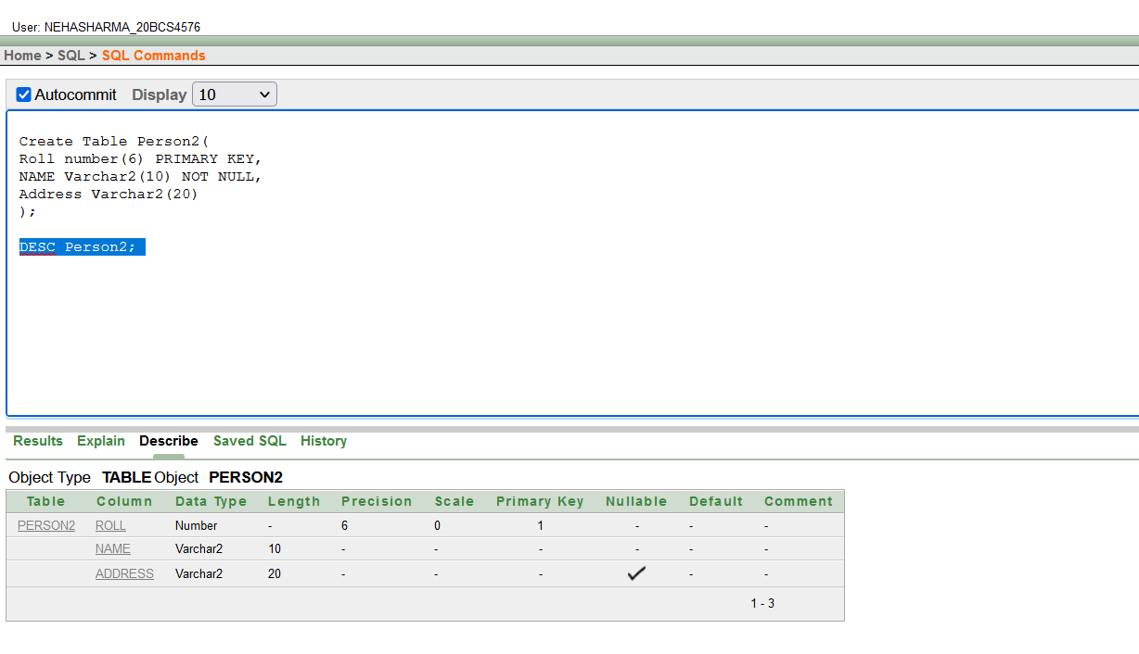

Defined at table level:

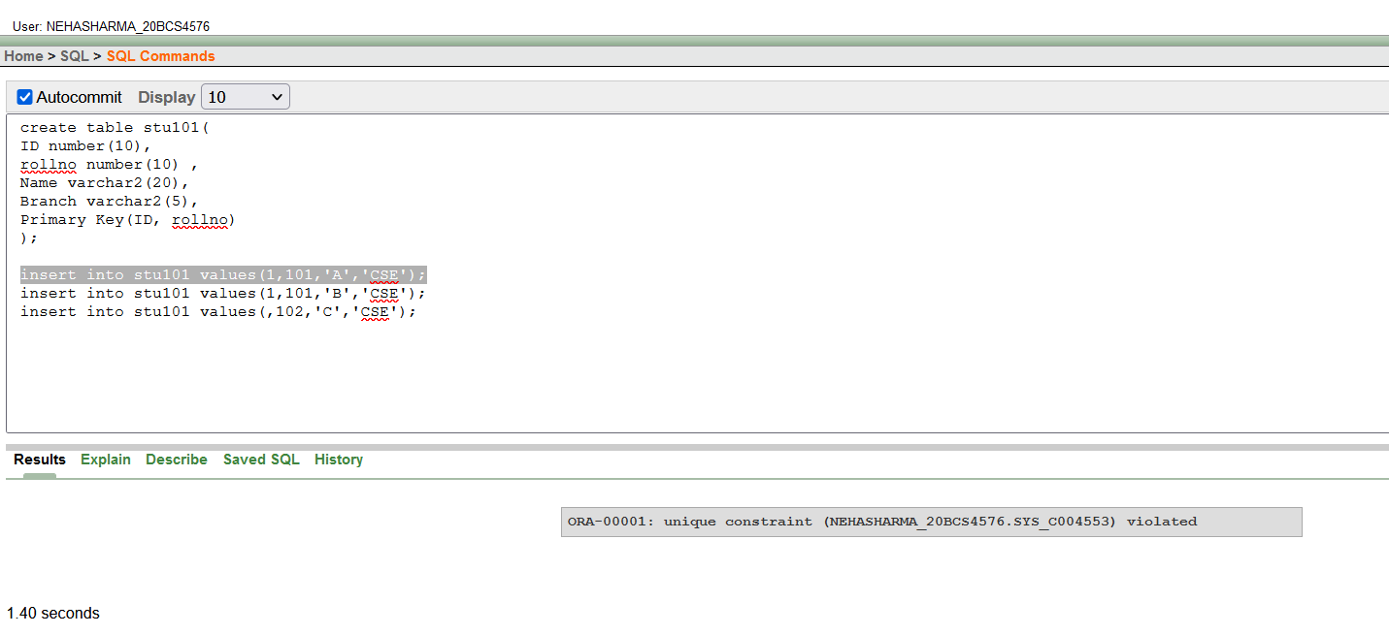

**4. Adding a Foreign Key-:**

**Command:** - Foreign Key

**Purpose: -** A foreign key is a column or group of columns whose values are derived from the primary key or unique key of some other table. If the name of the column is not specified, by default oracle uses primary key in the master table.

**Syntax: -** Defined at column level:

Column name datatype(size) References table name [(column name)] [On Delete Cascade]

**Defined at table level:** Foreign Key(column name[, column name]) References table name [(column name [,column name])

**Example: -**

**Defined at column level:**

Create Table DEPARTMENT ( Deptno Number(2) Primary key, Dname Varchar2 (15) Not Null, Dlocate Varchar2(20) );

create table employees( EMPNO1 int Primary Key, ENAME Varchar2(20) Not Null, JOB Varchar2(20), MGR Number(4), HIREDATE Date, SAL number(7), COMM number(10),

DEPTNO number(2), **REFERENCES** DEPARTMENT(DEPTNO) );

insert all

into department values(54,'VC','CHD') into department values(55,'CONTRACTOR','MUM') into department values(56,'MANAGER','CHEN') into department values(57,'MD','GOA') into department values(58,'CEO','DEL') select * from dual;

INSERT all into employees values(108,'NIMS','manager',45,sysdate+10,60000,10000,58) into employees values(107,'RIYA','jk',45,'01-jun-19',10000,500,57) into employees values(106,'SAM','guard',45,'02-jun-21',10000,500,56) into employees values(105,'DHRUV','gr',45,'04-jun-02',120000,5000,55) into employees values(104,'KIMI','rep',45,'01-jun-09',10000,500,54) select * from dual;

**Output:-**

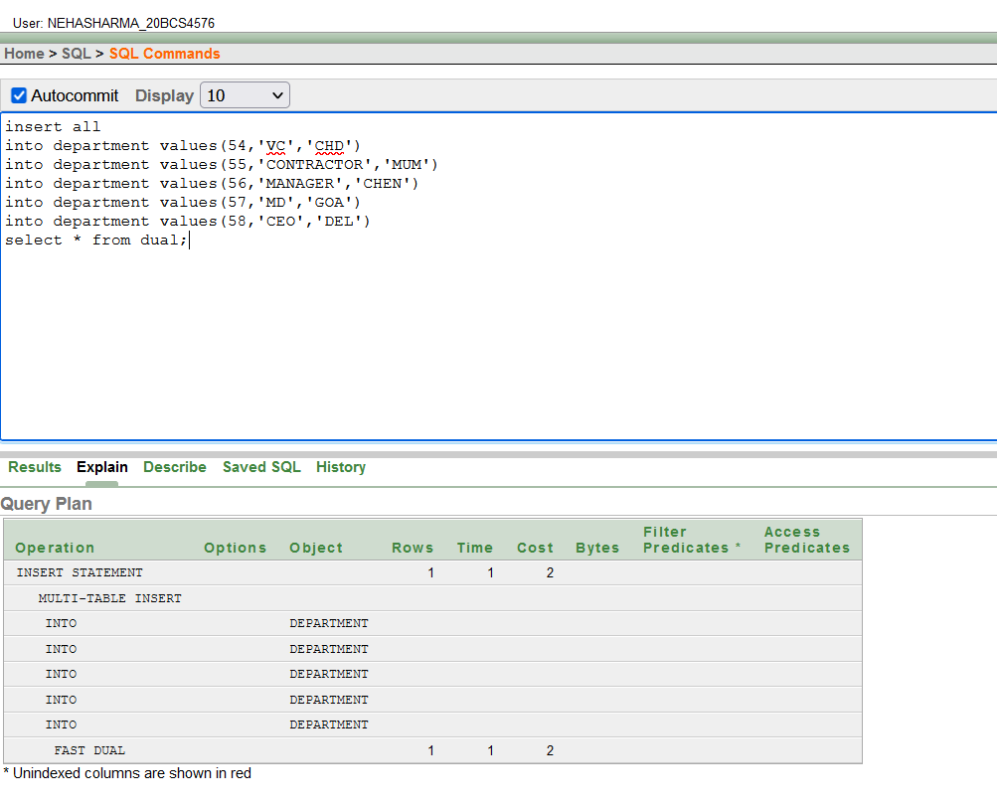

**Defined at table level:**

Create Table DEPARTMENT ( Deptno Number(2) Primary key, Dname Varchar2 (15) Not Null, Dlocate Varchar2(20) );

create table employees( EMPNO1 int Primary Key, ENAME Varchar2(20) Not Null, JOB Varchar2(20), MGR Number(4),

HIREDATE Date, SAL number(7), COMM number(10), DEPTNO number(2), foreign key(DEPTNO) REFERENCES DEPARTMENT(DEPTNO)

);

insert all into department values(54,'VC','CHD') into department values(55,'CONTRACTOR','MUM' ') into department values(56,'MANAGER','CHEN') into department values(57,'MD','GOA') into department values(58,'CEO','DEL') select * from dual;

INSERT all

into employees values(108,'NIMS','manager',45,sysdate+10,60000,10000,58) into employees values(107,'RIYA','jk',45,'01-jun-19',10000,500,57) into employees values(106,'SAM','guard',45,'02-jun-21',10000,500,56) into employees values(105,'DHRUV','gr',45,'04-jun-02',120000,5000,55) into employees values(104,'KIMI','rep',45,'01-jun-09',10000,500,54) select * from dual;

**Output: Both level of definition of foreign key has the same output**

**5. JOINS-:**

**Command:** - INNER JOIN

**Purpose**: - Inner joins are also known as Equi join. Sometimes it is necessary to work

with multiple tables as though they were a single entity. Then a single SQL sentence can

manipulate data from all the tables. Joins are used to achieve this.

select <column name 1>,….,< column name N> from <Table name1> **Inner join <**table name2> O**N** <Table name1>**.**<column name> = <Table name2>**.**<column name> **Where** <condition> **Order By** column name 1>,….,< column name N>;

**Example:-**

select E.eid, E.ename, P.Pid, P.Pname, P.Proj_duration from INSTRUCTOR E **inner join** Project101 P on E.Eid=P.Eid;

**Output:-**

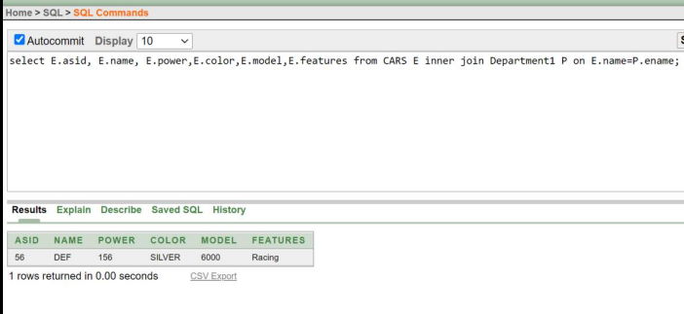

**6. Create SIMPLE index:**

Command: - create index

**Purpose:** - Indexing a table is an access strategy, i.e., a way to sort and search records in the

table. Indexes are essential to improve the speed with which record(s) can be located and

retrieved from a table.

**Syntax:** - Create Index < index name > On

|  |
| --- |
| ();  Example: create index index101 on CARS(asid,name); |

**Output:-**

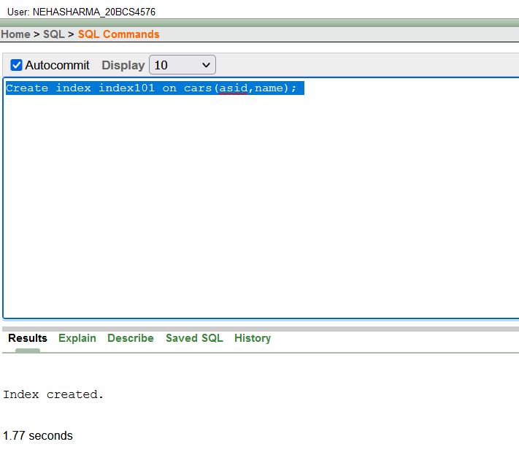

7. **Create UNIQUE index:**

**Command:** - create UNIQUE index

**Purpose:** - Creates a unique index on a table. Duplicate values are not allowed.

**Syntax:** - Create Unique Index < index name > On

|  |
| --- |
| ();  **Example:**  create UNIQUE index index104 on department1(eaddress,age); |

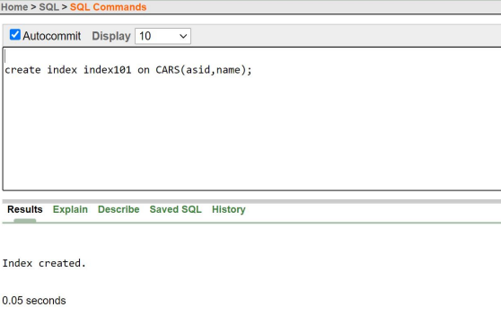

**8. Remove Index From INSTRUCTOR table:**

**Command:** - Drop Index

**Purpose: -** To drop all the indexes create don INSTRUCTOR table.

**Syntax: -** Drop index ;

**Example:** drop index index101;

**Output:**

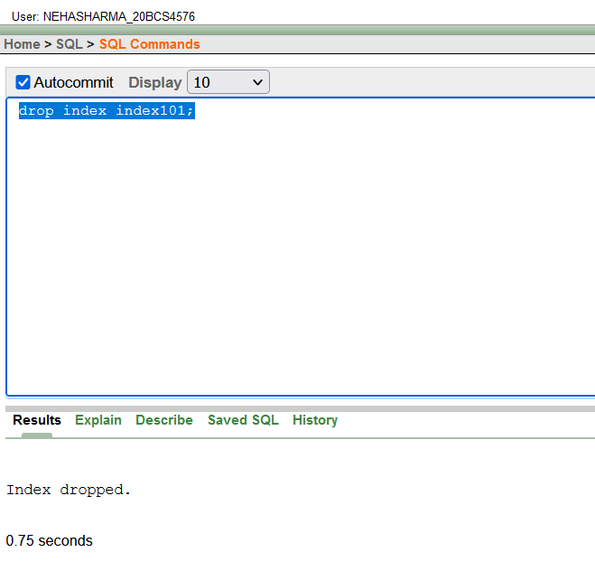

**9. Create a view:**

**Command**: - Create view

**Purpose:** - If a user wants to see only relevant

data then he/she can use views.

**Syntax:** - Create view AS Select ;

**Example**: Create view View101 as select eno,ename from department1;

**Output:-**

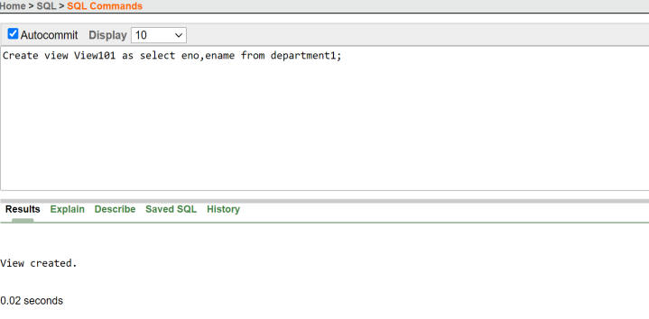

**10. Creating a sequence**

**Command:-** create sequence

**Purpose:-** Oracle provides an object called a sequence that can generate numeric values. A sequence can be defined to generate numbers in ascending or descending order, provide intervals bteween numbers, caching of sequence of numbers in memory to sped up their availability.

**Syntax:-**

**CREATE SEQUENCE** <sequence name>

**[INCREMENT BY** <integer value>

**START WITH** <integer value>

**MAXVALUE** <integer value>/NOMAXVALUE

**MINVALUE** <integer value>/NOMINVALUE

**CYCLE / NOCYCLE CACHE**<integer value> / NOCACHE ORDER/ NOORDER];

**Example:-**  create sequence seq101 increment by 1 maxvalue 20 nocycle order start with 1;

CREATE SEQUENCE emp_sequence

     INCREMENT BY 1

     START WITH 1

     NOMAXVALUE

     NOCYCLE

     CACHE 10;

**Output:-**

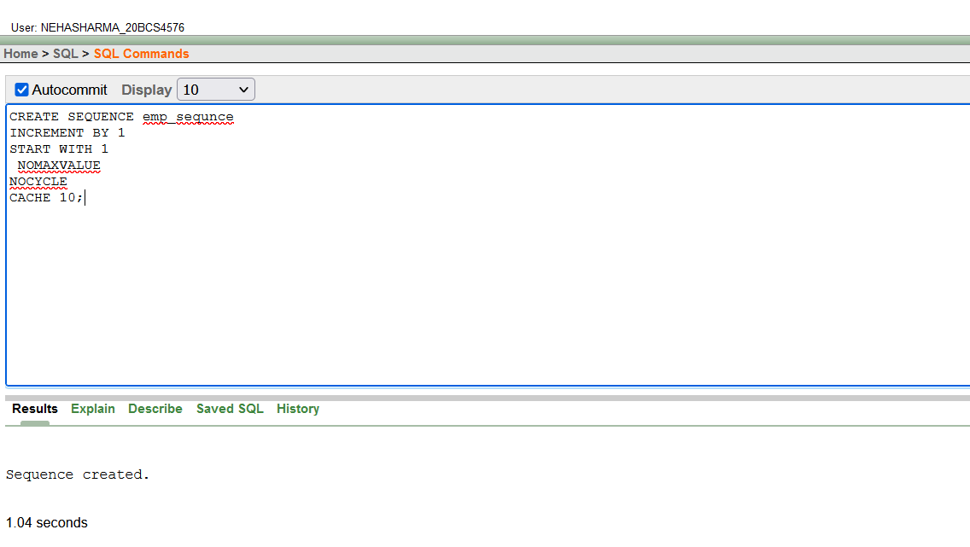

**4. Observations/Discussions:-** We observed the different syntax of implementing constraints on created table in SQL.

**5. Result/Output/Writing Summary:-** After completing this experiment we get to know constraints types in SQL and its implementation on table like JOINS, SEQUENCE, VIEW CREATION and FOREIGN KEY.

**6. Graphs (If Any): Image/Soft copy of graph paper to be attached here:- NA**

**Learning outcomes (What I have learnt):**

**1. We learnt different syntax of implementing constraints on created table in SQL.**

**2. After completing this experiment we get to know constraints types in SQL and its**

**implementation on table like JOINS, SEQUENCE, VIEW CREATION and FOREIGN KEY.**

**Evaluation Grid (To be created as per the SOP and Assessment guidelines by the faculty):**

|  |  |  |  |
| --- | --- | --- | --- |
| Sr. No. | Parameters | Marks Obtained | Maximum Marks |
| 1. |  |  |  |
| 2. |  |  |  |
| 3. |  |  |  |
|  |  |  |  |